Location of Ist Congress Centre
at Instituto Superior Técnico
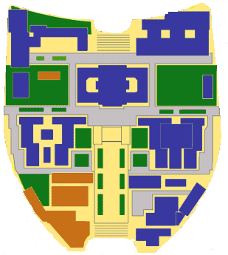
INSTITUTO SUPERIOR TÉCNICO
Unit of Marine Technology and Engineering
Congress Centre
Civil Engineering Building
Av. António José de Almeida
Av. Rovisco Pais

Av. Alves Redol

Av. Manuel da Maia

Location of Instituto Superior Técnico
AND SURROUNDING AREA

(INDICATING LOCATION OF RECOMMENDED HOTELS)

Location Map of IST and surroundings areas

Hotel Roma
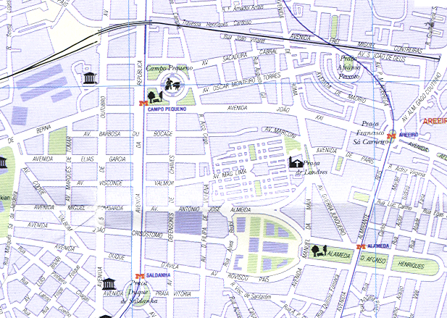
Hotel Holiday Inn
Hotel Lutécia

Instituto Superior Técnico
Hotel Dom Manuel
Hotel Marquês de Sá
A.S. Lisboa Hotel

recommended hotels in Lisbon
(close to IST)

Hotel Holiday Inn  Av. Antonio Jose de Almeida, 28-A  1000-044 Lisboa  Tel: +351-210044000  Fax: +351-217938374  Web: http://www.holiday-inn.com/lisbonprt  Prices from:  Single room: EUR 80,00 include breakfast  Double room: EUR 90,00 include breakfast  (IST Special Rates)  Walking distance from IST: 5 minutes | Hotel A.S. Lisboa  Av. Almirante Reis, 188  1000 Lisboa  Tel: +351-218429360  Fax: +351-218429374  Web: http://www.hotel-aslisboa.com  Prices from:  Single room: EUR 53,61  Double room: EUR64,60  (IST Special Rates)  Walking distance from IST: 10 minutes  Close to Metro Station 'Alameda'
Hotel Roma  Avenida de Roma, 33  1700 Lisboa  Tel: +351-217932244  Fax: +351-217932981  e-mail: reservas@hotelroma.pt  Web: http://www.hotelroma.pt  Prices from:  Single room: EUR 65,00 include breakfast  Double room: EUR 75,00 include breakfast  Walking distance from IST: 15 minutes | Hotel Lutécia  Av. Frei Miguel Contreiras, 52  (close to Av. de Roma)  1749-086 Lisboa  Tel: +351 21 841 1301  Fax: +351 21 840 7818  e-mail: lutecial@mail.telepac.pt  Web: http://www.hotel-lutecia.pt  Prices from:  Single room: EUR 60,00 include breakfast  Double room: EUR 70,00 include breakfast  Walking distance from IST: 15 minutes
Hotel Marquês de Sá  Av. Miguel Bombarda, 130  1050-157 Lisboa  Tel: +351-217 911 014  Fax: +351-217 936 983  http://www.hotelmarquesdesa.pt  Prices from:  Single room: EUR 53,50 include breakfast  Double room: EUR 62,00 include breakfast  Walking distance from IST: 15 minutes | Hotel Dom Manuel  Av. Duque d’Ávila, 189  1050-082 Lisboa  Tel: +351-213 593 000; Res: +351-213 593 010  Fax: +351-213 576 985  http://www.hoteldmanuel.pt  Prices from:  Single room: EUR 57,50 include breakfast  Double room: EUR 67,50 include breakfast  Walking distance from IST: 15 minutes

